SAMPLE SUPERSTORE DATASET

PROJECT REPORT

NAME : Raksitha T
SUBJECT : Python analytics(Week 2 Assignment)
DATASET : Sample Superstore
Collab Link : https://colab.research.google.com/drive/1X0B3PVNjbWdTaMhoMCxk-Z1FEnzirdaL?usp=sharing

1.OBJECTIVE
The primary objective of this project is to perform comprehensive Exploratory Data Analysis
(EDA) on the Sample Superstore dataset using Python libraries (Pandas, Seaborn, Matplotlib).
The evaluation encompasses data cleaning (checking missing values, duplicates, and data types),
summary statistics, outlier analysis, univariate order distributions, bivariate sales/profit
comparisons, and correlation analysis. The resulting insights profit leaks and present actionable
growth opportunities for strategic decision-making.

2.KEY VISUALIZATION
Figure 1: Number of Orders by Category
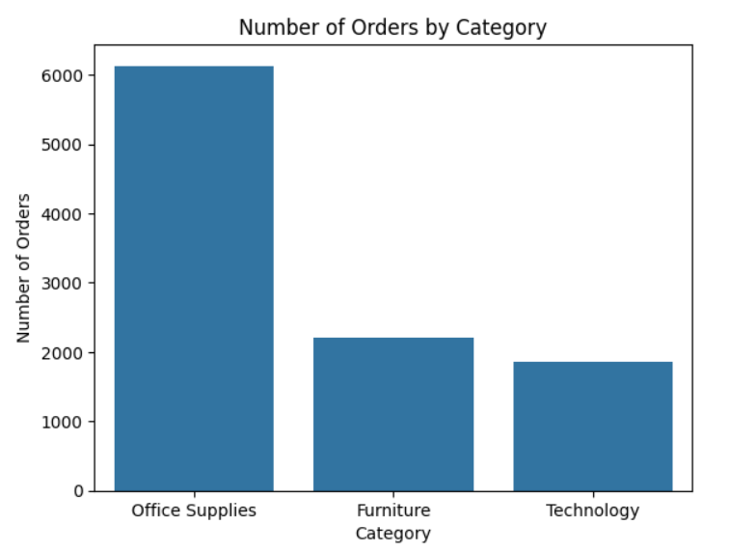

Figure 2: Number of Orders by Customer Segment & Region
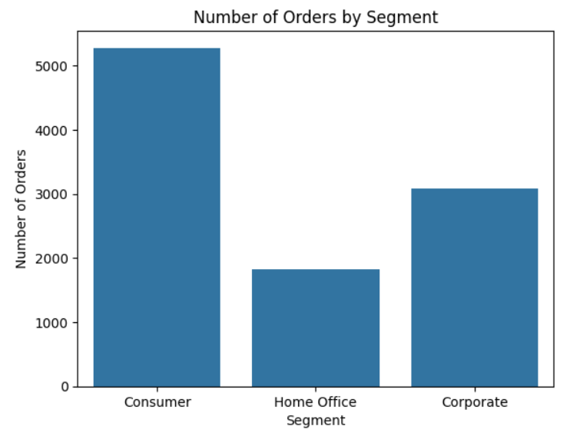
Figure 3: Average sales by category
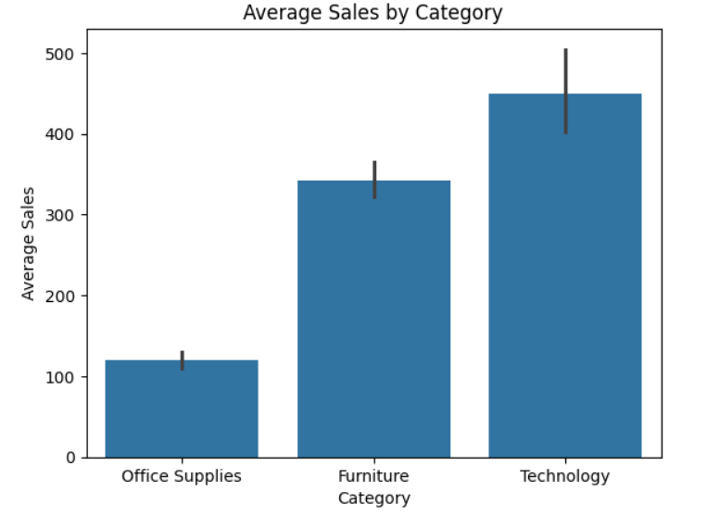
Figure 4: Average profit by category

Figure 4: Average profit by category

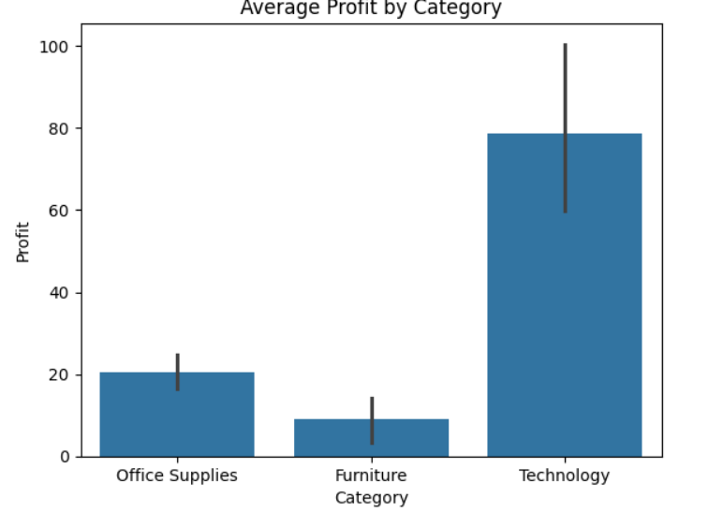

Figure 4: Discount vs. Profit Scatter Plot

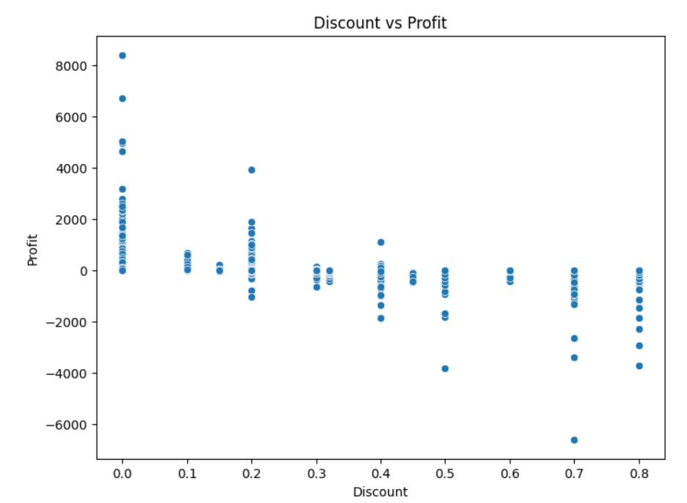

Figure 5: Correlation Heatmap

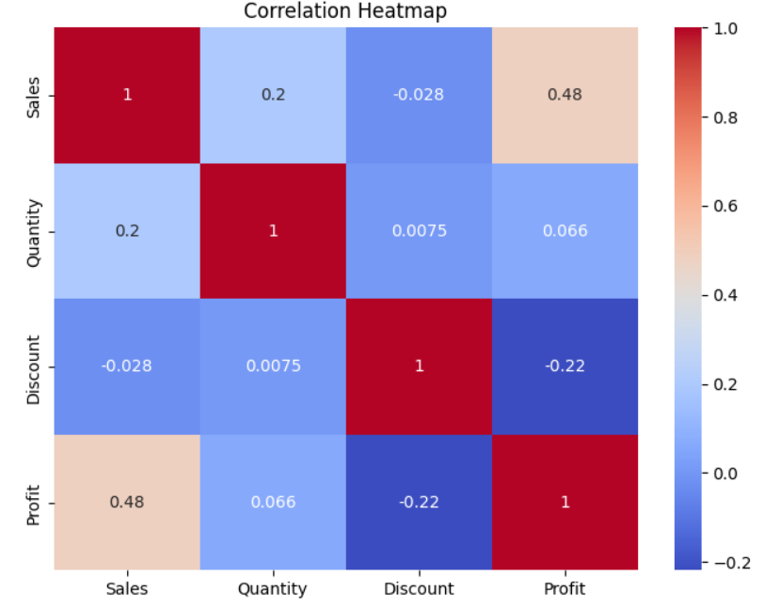

3.Keyfindings and business
- Category performance:
Technology generates the highest average sales and highest average profit per transaction, making it the most profitable category despite having the lowest total order count. Office Supplies dominates transaction volume with >6,000 orders, delivering modest but consistent margins. Furniture registers strong average sales but yields very low profit margins.
- Sub-Category Analysis:
High-tech items like Copiers, Phones, and Accessories serve as primary business drivers. Conversely, sub-categories like Tables and Bookcases undergo significant margin compression due to high freight costs and aggressive pricing markdowns.

- Discount Impact:
The scatter plot clearly demonstrates that discounts between 0.0 (0%) and 0.20 maintain stable positive profits. However, discounts exceeding 0.20 trigger sharp profit declines, with discounts of 0.50 to 0.80 consistently resulting in massive net losses.
- Sales vs Profit relationship :
The statistical summary confirms a maximum single transaction sale of $22,638.48 and maximum profit of $8,399.98. However, high top-line sales do not guarantee positive profit, as evidenced by a minimum profit of on a high-value order due to steep discounting.
- Correlation Analysis:
The calculated correlation matrix reveals a moderately strong positive correlation between Sales and Profit, confirming that larger order values drive higher profits under normal pricing. Especially, Discount has a clear negative correlation with Profit, confirming that discounting directly destroys bottom-line profits.
4. Profit Leaks
- Loss-Making Sub-Categories:
Furniture sub-categories (specifically Tables and Bookcases) accumulate severe net losses due to low base profit margins combined with high shipping overheads.
- High Discounts with Negative Profit:
Offering heavy promotional discounts in the 30% to 80% range (discount values 0.3 to 0.8) severely damages profitability, creating the largest individual losses in the dataset.
- Regions with Poor Profitability:
Central and South regions lag in profitability relative to West and East, driven by higher average discount rates offered to close deals in those territories.
- High Sales, Low Margin Items:
High-dollar sales in Furniture generate substantial topline revenue but contribute almost zero net profit, consuming working capital and operational bandwidth.

5. Growth Opportunities
- Highly Profitable Categories:
Business strategy and marketing investments should prioritize high-margin segments specifically Technology which generates the highest average net return. As shown in the Profit by Category and Profit Distribution by Category charts, expanding sales volume in high-profit categories increases overall net earnings without inflating operational costs.

- Products with Strong Sales and Profit:
The store should focus on promoting core high performing product categories that demonstrate both strong total revenue and healthy positive margins (e.g., Technology and Office Supplies). As reflected in the Correlation Heatmap focusing on these top-tier offerings ensures sales growth directly drives net profit.

